Assignment

Milestone One Submission

2805ICT/3815ICT/7805ICT

Group Number: 10

**Student name:** Daniel De Calmer **Student ID:** s5294811 **Enrolled Course Code:** 3815ICT

**Student name:** Anton Koulakov **Student ID:** s5297083 **Enrolled Course Code:** 3815ICT

**Student name:** Draco Zhang **Student ID:** s5286938 **Enrolled Course Code:** 3815ICT

**Student name:** Elijah De Calmer **Student ID:** s5264616 **Enrolled Course Code:** 3815ICT

# Table of Contents

Table of Contents 2

1.0 Project Planning and Documentation 3

1.1 Time Schedule 3

1.2 Total working hours 3

1.3 Effort and contribution table 3

1.4 Version Control System 4

2.0 Requirements Analysis 4

2.1 Functional requirements 4

2.2 Non-functional requirements 4

2.3 Use case diagram 4

2.4 Full use case description 4

2.5 Activity diagram 4

3.0 Video link 4

# 1.0 Project Planning and Documentation

## 1.1 Time Schedule

This table should reflect who did what, how long you expected sections to take and the actual hours it took to perform the tasks.

|  |  |  |  |  |  |  |  |  |
| --- | --- | --- | --- | --- | --- | --- | --- | --- |
| **Task** | | **Plan** | | | | **Actual** | | |
| # | Task Name | Student | Planned Time | Cumulative  Time | Finished Date | Time | Cumulative Time | Finished Date |
| 1 | Devise Project Plan | Anton | 1 day | 1 day | 29/07 | 1 day | 1 day | 29/07 |
| 2 | Identify Functional Requirements | Daniel | 1 day | 2 days | 30/07 | 1 day | 2 days | 30/07 |
| 3 | Identify Non-Functional Requirements | Daniel | 1 day | 3 days | 31/07 | 1 day | 3 days | 08/08 |
| 4 | Create Use Case Diagram | Daniel | 2 days | 5 days | 02/08 | 1 day | 3 days | 08/08 |
| 5 | Create Activity Diagram | Daniel | 1 day | 6 days | 05/08 | 1 day | 4 days | 09/08 |
| 6 | Create Main Menu | Daniel | 1 day | 7 days | 06/08 |  |  |  |
| 7 | Create Splash Window | Elijah | 1 day | 8 days | 07/08 |  |  |  |
| 8 | Code Gameplay (including row erasure) | Anton | 4 days | 12 days | 13/08 |  |  |  |
| 9 | Implement Pause Functionality | Draco | 1 day | 13 days | 14/08 |  |  |  |
| 10 | Implement Back & Exit Buttons | Draco | 1 day | 14 days | 15/08 |  |  |  |
| 11 | Create High Score Screen | Elijah | 1 day | 15 days | 16/08 |  |  |  |
| 12 | Create Configuration Screen | Draco | 1 day | 16 days | 19/08 |  |  |  |
| 13 | Test Software | Draco | 2 days | 18 days | 21/08 |  |  |  |
| 14 | Record Demo Video | Elijah | 1 day | 19 days | 22/08 |  |  |  |
| 15 | Assemble Peer Reviews and Create Summary | Anton | 1 day | 20 days | 23/08 |  |  |  |

Note – weekend days are ignored for the planned time.

## 1.2 Group Meeting Records

[Group meeting is important for group project, please record group meeting. Date, time attendance, online or face to face meeting. And also report any software tools used for manage the group project ]

## 1.3 Effort Summary

|  |  |  |
| --- | --- | --- |
| **Student Name (#ID)** | **Plan (hours)** | **Actual (hours)** |
| Daniel De Calmer (5294811) |  |  |
| Anton Koulakov (5297083) |  |  |
| Draco Zhang (5286938) |  |  |
| Elijah De Calmer (5264616) |  |  |
| **Total working hours** |  |  |
| **Average working hours per person** |  |  |

## 1.4 GitHub Repository

[dwacochan/Enhanced-Tetris (github.com)](https://github.com/dwacochan/Enhanced-Tetris)

[NEED SCREENSHOT OF GIT COMMITS]

# 2.0 Requirements Analysis

## 2.1 Functional Requirements

* **ID:** FR-001
  + **Title:** Load into main menu
  + **Precondition:** The application is started
  + **Event:** User starts the application
  + **Postcondition:** Splash screen is displayed, and main menu is loaded
  + **Constraints:** Splash screen will be a set length of time (maybe 1 second)
* **ID:** FR-002
  + **Title:** Display main menu
  + **Precondition:** Application is started, and splash screen is displayed
  + **Event:** Splash screen fades away
  + **Postcondition:** Main menu is displayed
* **ID:** FR-003
  + **Title:** Start Game
  + **Precondition:** Main menu is displayed
  + **Event:** User clicks on the Play button
  + **Postcondition:** Game screen is displayed, and game starts
* **ID:** FR-004
  + **Title:** Display game screen elements
  + **Precondition:** User starts the game
  + **Event:** Game screen is loaded
  + **Postcondition:** Window for game, live score number, current level number, and next tetromino are displayed
  + **Constraints:** Elements must be clear and non-obstructive
* **ID:** FR-005
  + **Title:** Music and sound effects shortcut keys
  + **Precondition:** Game is in progress
  + **Event:** User presses shortcut keys
  + **Postcondition:** Music and sound effects are toggled
  + **Constraints:** Keys must be easy to remember and use
* **ID:** FR-006
  + **Title:** Control falling tetrominoes
  + **Precondition:** Game is in progress
  + **Event:** User interacts with control keys
  + **Postcondition:** Tetrominoes move according to user input
  + **Constraints:** Controls must be responsive
* **ID:** FR-006-1
  + **Title:** Increase rate of falling
  + **Precondition:** Tetromino is falling
  + **Event:** User holds down the fall key
  + **Postcondition:** Tetromino falls faster
* **ID:** FR-006-2
  + **Title:** Flip Direction
  + **Precondition:** Tetromino is falling
  + **Event:** User presses the flip key
  + **Postcondition:** Tetromino flips direction
* **ID:** FR-006-3
  + **Title:** Move left and right
  + **Precondition:** Tetromino is falling
  + **Event:** User presses left or right key
  + **Postcondition:** Tetromino moves left or right
  + **Constraints:** Must be smooth and responsive
* **ID:** FR-006-4
  + **Title:** Immediate drop
  + **Precondition:** Tetromino is falling
  + **Event:** User presses the drop key
  + **Postcondition:** Tetromino drops immediately to the bottom
* **ID:** FR-007
  + **Title:** Erase completed lines
  + **Precondition:** Tetrominoes fill one or more lines completely
  + **Event:** Line(s) are completed
  + **Postcondition:** Completed line(s) are erased
  + **Constraints:** Erasure is immediate and followed by score update
* **ID:** FR-008
  + **Title:** Pause and resume game
  + **Precondition:** Game is in progress
  + **Event:** User presses the ‘p’ key
  + **Postcondition:** Game pauses or resumes and shows text if needed
* **ID:** FR-009
  + **Title:** Back button functionality
  + **Precondition:** Game is in progress
  + **Event:** User presses the back button
  + **Postcondition:** Confirmation window is displayed, and user can choose to quit or resume
* **ID:** FR-010
  + **Title:** Display Configuration Options
  + **Precondition:** Main menu is displayed
  + **Event:** User navigates to the configuration screen
  + **Postcondition:** Sliders and tick boxes for configuration options are displayed
* **ID:** FR-011
  + **Title:** Display high scores
  + **Precondition:** Main menu is displayed
  + **Event:** User navigates to the high scores screen
  + **Postcondition:** High scores table is displayed
  + **Constraints:** Updated as soon as new high score is set, and displayed in descending order
* **ID:** FR-012
  + **Title:** Exit Application
  + **Precondition:** Main menu is displayed
  + **Event:** User clicks the exit button
  + **Postcondition:** Confirmation window is displayed
  + ‘No’ closes text window
* **ID:** FR-012-1
  + **Title:** Confirm Exit
  + **Precondition:** User clicks exit button
  + **Event:** User clicks ‘yes’ on the confirmation window
  + **Postcondition:** Application closes
* **ID:** FR-012-2
  + **Title:** Cancel Exit
  + **Precondition:** User clicks exit button
  + **Event:** User clicks ‘no’ on the confirmation window
  + **Postcondition:** Confirmation window closes

## 2.2 Non-functional Requirements

**Usability**

* **ID:** NFR-001
  + **Title:** Intuitive User Interface
  + **Description:** The game should have an intuitive and user-friendly interface.
  + **Metric:** User feedback should indicate this.
  + **Priority:** High
* **ID:** NFR-002
  + **Title:** Easy Navigation
  + **Description:** Users should be able to easily navigate through the game’s menus and options.
  + **Metric:** Users should be able to access any menu or option within three clicks.
  + **Priority:** High

**Reliability**

* **ID:** NFR-003
  + **Title:** Error Handling
  + **Description:** The game should handle errors gracefully without crashing.
  + **Metric:** The game should recover from errors within 5 seconds and display a user-friendly error message.
  + **Priority:** High

**Performance**

* **ID:** NFR-004
  + **Title:** Fast Load Times
  + **Description:** The game should load quickly.
  + **Metric:** The game should load the splash screen within 2 seconds and the main menu within 3 seconds.
  + **Priority:** High
* **ID:** NFR-005
  + **Title:** Smooth Gameplay
  + **Description:** The game should run smoothly without lag.
  + **Metric:** The gameplay should look visually smooth instead of laggy.
  + **Priority:** High

**Supportability**

* **ID:** NFR-006
  + **Title:** Easy Maintenance
  + **Description:** The game code should be easy to maintain and update.
  + **Metric:** Code should be well-documented, and new features or bug fixes should take no more than 2 hours to implement.
  + **Priority:** Medium

**Aesthetics (Additional Qualities)**

* **ID:** NFR-007
  + **Title:** Visual Appeal
  + **Description:** The game should have visually appealing graphics and animations.
  + **Metric:** User feedback should reflect this.
  + **Priority:** Medium
* **ID:** NFR-008
  + **Title:** Consistent User Experience
  + **Description:** The game should provide a consistent user experience across all levels and menus.
  + **Metric:** User feedback should report minimal complaints about inconsistencies.
  + **Priority:** High

## 2.3 Use Case Diagram

## 2.4 Activity Diagram

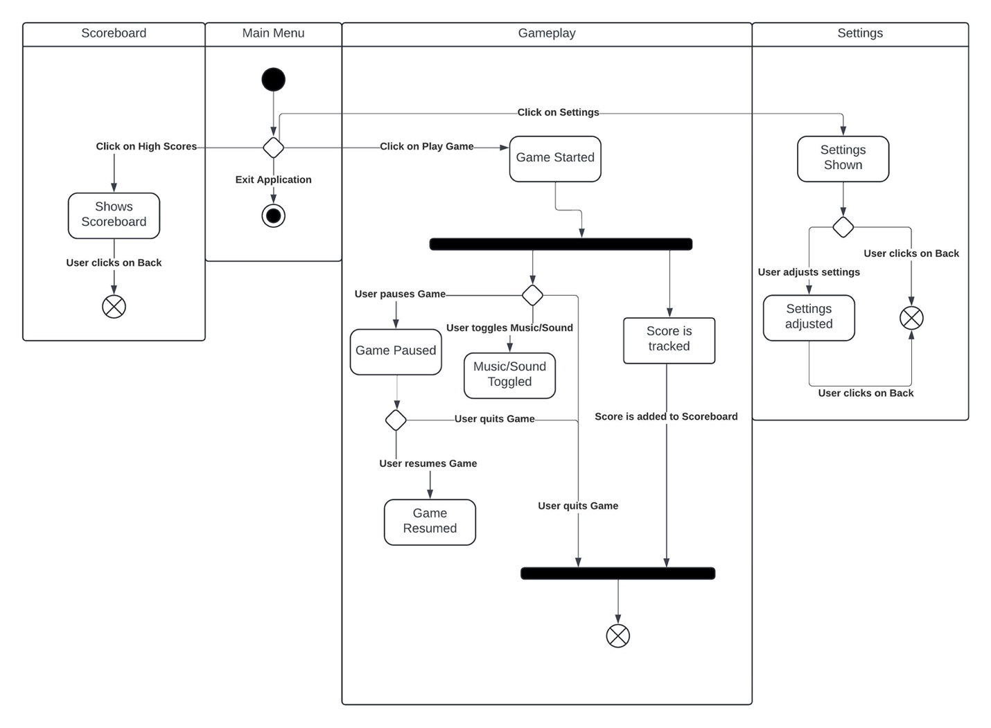

# 3.0 Peer Review

[To complete your peer review, you need to:

1. Perform a self-review of your own performance. (see section 1 below)
2. Write a review for each team member (see section 2 below).

The whole group need to provide a summary table ]

## 3.1 [student’s name] review

### 3.1.1 Self Review

1. What is your role in this team?
2. What is your contribution so far (both in terms of quantity and quality)?
3. Comment on your professional conduct e.g. make yourself available for meetings, shows up to meeting (on time), respect other team members, willingness to help, positive attitude, provide constructive feedback, submit on time etc.
4. How can you do better? How can you better contribute to the team?
5. Rate your performance out of 10.

3.1.2 Review Team Members

For each team member provide:

1. What is the name of the team member and what is this team member’s role?
2. What is this team members contribution so far (both in terms of quantity and quality)?
3. Comment on this team member’s professional conduct e.g. make him/herself available for meetings, shows up to meeting (on time), respect other team members, willingness to help, positive attitude, provide constructive feedback, submit on time etc.
4. Provide any constructive suggestion for this team member on how s/he could better contribute to the team.
5. Rate this team member out of 10.

## 3.2 [Another student’s name] review.

[same as the section 3.1]

## 3.3 [Repeat for each of the team members]

## 3.x Summary

[Please edit the review summary table below. Left column are the name of the students who give the review score, the first row are the students who receive the review score. The score is from 0 to 10]

|  |  |  |  |  |  |
| --- | --- | --- | --- | --- | --- |
|  | Member 1 | Member 2 | Member 3 | Member 4 | Member 5 |
| Member 1 | 10 | 10 | 10 | 10 | 10 |
| Member 2 | 10 | 10 | 10 | 10 | 10 |
| Member 3 | 10 | 10 | 10 | 10 | 10 |
| Member 4 | 10 | 10 | 10 | 10 | 10 |
| Member 5 | 10 | 10 | 10 | 10 | 10 |
| Total Score | 50 | 50 | 50 | 50 | 50 |
| Average Score | 10 | 10 | 10 | 10 | 10 |

[Based on individual student’s average review score, the student’s mark would be adjusted based on the table below]

|  |  |
| --- | --- |
| % of APRS above/below group average | Change to individual's score (CIS) |
| Over 50% | Decision from teaching team |
| 40% to 50% | +30% |
| + 21% to + 40% | +20% |
| + 11% to 20% | +10% |
| + or - 10% | 0 |
| -11% - 20% | -10% |
| -21% to -40% | -20% |
| -40% to -50% | -30% |
| Over -50% | Decision from teaching team |

# 4.0 Reflection

[each of the master student in the group need to provide a one page reflection, details please check the assignment specification.]

## 4.1 [name’s] Reflection

## 4.2 [another master student’s name] Reflection

# 5.0 Video link

[please put the URL of your video, and make sure that the video can be viewed by the assessor]